**R&D Technology Field Trial Plan for APC with Virgin Rail at Crewe, UK**

**Scope of Work - Project Proposal**

**Prepared by PSNLE, Feb 2014**

**Automatic Passenger Counter (APC)**

* Panasonic is currently developing an Automatic Passenger Counter (APC) for on-board train.
* APC is designed specifically to count people coming in and out of trains and moving across carriages
* Data collected from APC can help to improve passenger journey experience and enhance overall satisfaction.
* The Panasonic APC system is not commercially ready (Technology Readiness Level 4). The system requires further testing and modification. (<http://en.wikipedia.org/wiki/Technology_readiness_level>)

**Background**

* On June 13th 2014, Panasonic and Virgin Rail established a MoU in regards to trialling for future technologies with the view to help improve Virgin Train operations and customer satisfaction purpose.
* On July 17th 2014, Panasonic visited Virgin Rail Education Centre in Crewe, UK accompanied by Rob Walker (Fleet Quality and Safety Assurance Manager).
* In Crewe, Virgin Rail have a 2-carriages Demo train which is a retired Pendolino train from 2007. The train is currently used for training and education purposes.
* The visit was to understand if Panasonic could conduct an APC technology trial and to understand Virgin Rail’s requirements. Panasonic was asked to come back with a scope of work proposal

**Benefit to Virgin Rail**

* **Direct benefit to improve Virgin’s Advocacy Score**: knowing the occupancy level per carriage level to improve the passenger experience by minimizing overcrowding and spreading passengers (without reservation) across all carriages.
* **Load Monitoring to improve health and safety**: APC lets the train conductor know the passengers occupancy to decide if ‘tilt mode’ should be operated or not
* **Operation efficiency**: Virgin Rail currently still conducts manual passenger count on-board. APC will be able to assist the counting and could also provide head office with more informed information with regards to ticketing vs actual occupancy.

**Goal of Trial**

To test the Technology feasibility of the Automatic Passenger counter (APC) in a controlled environment.

**Commercialisation Potential**

Not commercialised (To be determined after the trial)

**Duration of Trial**

16 Working Days (11 days on sites, 5 offsite days for preparation)

**After Trial**

Panasonic will be able to share the test result and discuss further together with Virgin Rail about their requirement for APC

**Cost of Trial to Virgin Rail**

Panasonic will pay for the cost of this trial.

We may ask if there are volunteers at Crewe Office to act as passengers for testing purposes. (Volunteers may be asked to sign a NDA for their participation??)

**Test Plan Description**

In this section, the overall approach to the deployment of the test system is explained.

Our proposed Test phases

1. **Site Survey (2 days):** Understand the capabilities and limitation of the test environment. Eg. power supplies, door control, cabling requirement
2. **Deployment of APC at test site (3 days):** Installation of APC system inside Demo Train. With a ‘non-environment damage’ set up. Eg. No drilling consideration
3. **Technology Evaluation Period (5 days):** Panasonic will provide engineers to test several scenarios. May require volunteer to act as passengers to walk in and out of the train (with permission of Virgin).
4. **Clean up (1 day):** To restore everything back to normal

**Timeline Chart**

Finish at Crewe

|  |  |  |  |  |  |  |  |  |  |  |  |  |  |  |  |  |  |
| --- | --- | --- | --- | --- | --- | --- | --- | --- | --- | --- | --- | --- | --- | --- | --- | --- | --- |
| Activity |  |  | WK1 | |  |  |  | WK2 | |  |  |  | WK3 | |  | WK4 | |
| Site Survey |  |  |  |  |  |  |  |  |  |  |  |  |  |  |  |  |  |
| Off site preparation |  |  |  |  |  |  |  |  |  |  |  |  |  |  |  |  |  |
| Deployment of APC on Demo Train |  |  |  |  |  |  |  |  |  |  |  |  |  |  |  |  |  |
| Evaluation Period |  |  |  |  |  |  |  |  |  |  |  |  |  |  |  |  |  |
| Clean up |  |  |  |  |  |  |  |  |  |  |  |  |  |  |  |  |  |
| Off Site Data Analysis |  |  |  |  |  |  |  |  |  |  |  |  |  |  |  |  |  |

Panasonic to continue APC Development

**Demo Train Test Environment**

The Demo train consists of 2 carriages - First Class, Dinning and 2nd Class seating and Train Control room and Kitchen compartments.

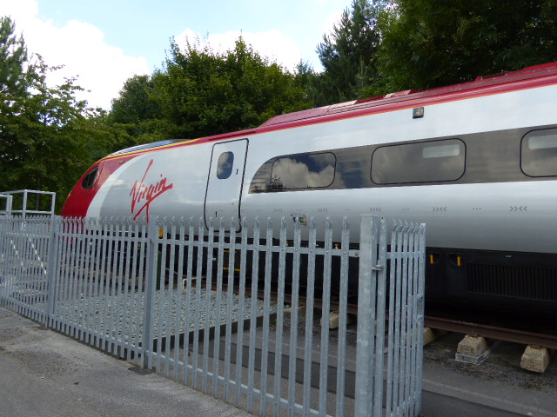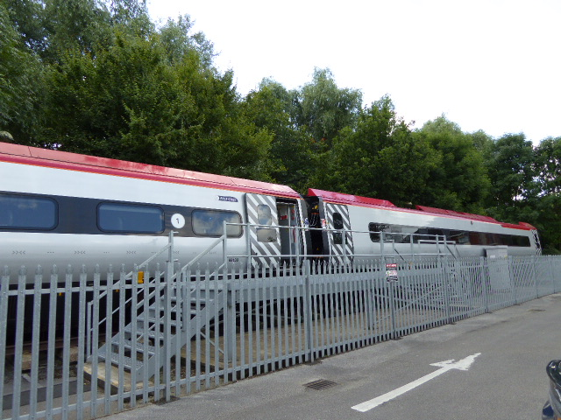

Staff Door

*Carriage 1*

*Carriage 2*

Driver Control

**Top View**

Platform

Kitchen

Fence

Passenger Door

Passenger Door

1st Class

Dining

2nd Class

Passenger Door

Passenger Door

Platform

Staff Door

*Carriage 1*

*Carriage 2*

**Side View**

* Only the middle 2 doors give access into the train.

**APC Installation**

We plan to put APC devices (see picture):

APC Device

Platform

Fence

*Carriage 1*

*Carriage 2*

Kitchen

1st Class

Dining

2nd Class

Driver Control

Top View

Virgin have requested to not leaving any permanent damage on the demo train, such as drilling holes and marking as the demo train.

Panasonic proposed to use special 3M tape adhesive on the back of the APC device.

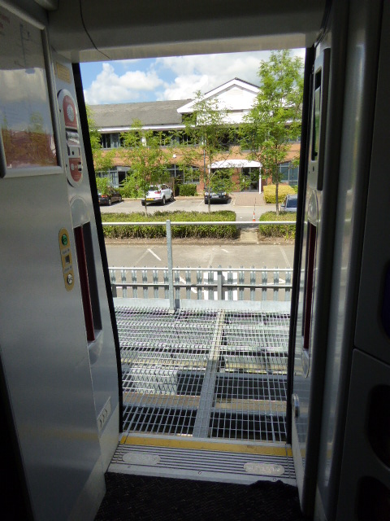

Sticky tape

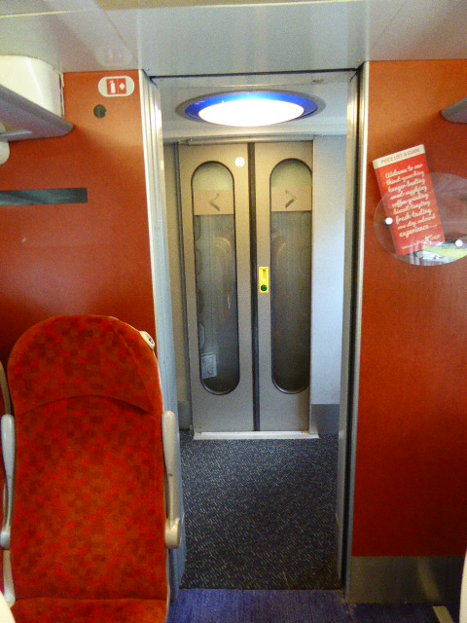

APC Device

**APC System Connection Plan**

PoE Hub

APC Device

Platform

*Carriage 1*

*Carriage 2*

AC 230V

(Sub)

(Master)

Kitchen

1st Class

Dining

2nd Class

Driver Control



Data Log PC

Top View

Multiple sensors are connected with PoE Hub via Ethernet, data is aggregated and passed to Engineer PC through Hub.

Data is gathered for Carriage 1 an Carriage 2 respectively.

Ethernet cables are wired temporally for testing purpose.

Panasonic need Power source at one point in each Carriage. (AC230V: TBD)